Horizontal Continuous Band Sealer

D 547 AHS

Equipped with:
Digital Control Panel

Technical
Specification Sheet
Rev.00
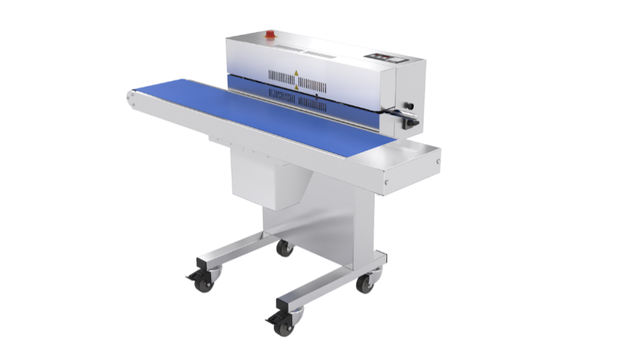 | 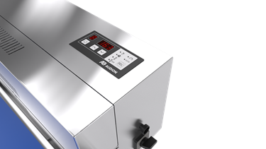

General specifications
Type of machine | Horizontal Continuous Band Sealer
Model | D 547 AHS
Machine dimensions WxDxH | 1424 x 582 x 1009 (with conveyor belt)
Weight | ~110 kg
Seal width | 10 mm (option 20 mm)
Seal system | Flat seal
Bag material | PE / PP /Cellophane / PVC, Paper laminates, (Alu) laminates up to 0,2mm
Material thickness | min. 25 / max. 150 micron
Bag length | min. 55 / max. 460 mm
Max. carrying weight | 10 kg
Control system | Digital membrane control panel
Data transfer | Not possible
Covering | Stainless steel
Sealing height  adjustable range | 835mm + 200 = max. 1035 mm
Conveyor belt height  adjustable range | 769 + 60mm = max. 829 mm
Conveyor belt width | 250 mm
Power supply | 230 V (option 115V) – 1ph – 50/60Hz
Power consumption | 1100 W
Noise level | < 85 dB(A)
IP rating | IP20
Applicable standards | EN-ISO 12100: 11-2010, EN-ISO 14118: 02-2018, EN-IEC 60204-1: 2018, EN-ISO 13732-1: 09-2008, EN-ISO 13850: 11-2015

Technical specifications
Recipe | Storage | 9 recipes
Process parameters | Seal temperature:  Setting range  Tolerance range | max. 250°C  Default 5 °C
 | Seal speed | Variable, up to 10 meters per minute

Machine dimensions
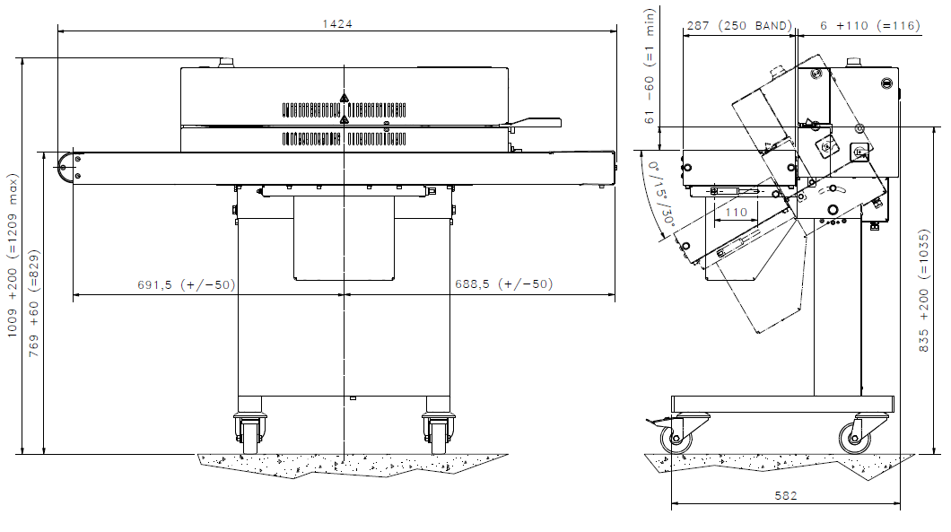

Bag size range
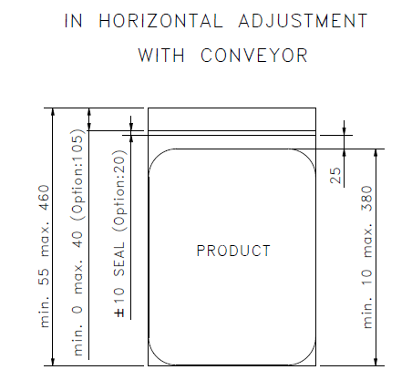

Options | Descriptions
Printer option: | Inkjet printer for adding personalized text, counter, date, expiry date, pictures and logos of JPG or BMP format and barcodes / QR codes.
PTFE protect program: | Enables you to keep the machine on the set seal temperature whilst temporarily not sealing bags. Prevents the PFTE belts from burning.
Extra seal width: | 20 mm (useful for bags with eurolog).
Operating direction: | Left to right (instead of right to left)
115V | Machine in 115V configuration (instead of 230V)

